**Droughts, Income Shock and Marriage Age**

DUYI LIU

Institute for Economic and Social Research

July, 2022

**Abstract**: This paper studies how negative income shocks affect the age of marriage of females, particularly early marriage in China. In many places in China, there are monetary transfers that occur with marriage: bride price and dowry. Income shocks may affect the age of marriage because marriage payments are a source of consumption smoothing, particularly for a woman's family. In this paper, I use droughts as a proxy for income shock. I found that with 1 unit of decrease in precipitation in the previous year or the current year, the girl's marriage age will be 0.3% earlier. In places that have higher bride prices, this number is 0.4%. The results indicate that the age of marriage responds to changes in aggregate economic conditions if the bride price exists. This suggests that regulating the high level of bride price and providing prompt and effective subsidies to families affected by income shock may be the solution to the phenomenon of early marriage.

**Keywords:** droughts, income shock, early marriage, bride price, female and children's wellbeing

1. INTRODUCTION

China introduced a minimum age of marriage law in 1980. This has, to some extent, limited the phenomenon of early marriage and early childbearing among Chinese female adolescents. However, data from related studies show that early marriage and childbearing among adolescents aged 15 to 19 still exist, especially in areas with lower economic levels and rural areas. The association between early female marriage and poor physical and socioeconomic outcomes is well established in the literature. Early marriage is associated with lower educational attainment, lower use of preventive health services, lower bargaining power within the household, physical abuse, and domestic violence. However, few have examined the important question of why these practices are still so prevalent in China and what effective policies are to reduce them.

The main goal of this paper is to find the relationship between negative income shock indicated by the droughts and marriage age when considering bride price. A daughter may be costly to support or can contribute to her household's budget through her labor supply or home production. Upon the marriage of a daughter, parents obtain a bride price payment. In this framework, a negative income shock is associated with an increase in the probability of marriage.

I test this prediction using a dataset from the China Health and Retirement Longitudinal Study(CHARLS), a nationally representative sample of Chinese residents. I also use the weather data from NOAA Center for Weather and Climate Prediction. In particular, I exploit exogenous variation in rainfall to estimate the causal effect of income shocks on the age of marriage. Negative rainfall shocks--droughts, measured as the absolute deviation of rainfall from the historical mean at the city level. To examine the relationship between rainfall shocks and time to marriage, I match each woman to the city where she grew up and reconstruct the model of rainfall shocks that she experienced. I also control for birth year fixed effects to account for changes at the marriage market level and for city fixed effects to account for changes in marriage timing across cities. I find that girls whose families experienced the negative rainfall shock in their teenage years have a higher probability of being married at an early age. By exploiting data on bride price amount, I also find that the relationship between female early marriage and negative income shocks is significantly strong in places where bride price payments are typically higher.

My paper is related to three strands of the literature on economics. The first is the literature on the relationships between weather shock and economic conditions. Baez J E et al (2017) identify the negative consequences of the strongest tropical storm ever to strike Guatemala on household welfare. Miguel E et al (2004) use rainfall variation as an instrumental variable for economic growth in 41 African countries.

Second, some papers study the economic condition and early marriage. The poor economic condition may lead to early marriage. Female adolescents residing in less-developed areas were more likely to engage in early marriage and childbirth. (Dong-mei LUO et al, 2020). On the other way around, early marriage will worsen the economic condition. Girls who marry early have little decision-making power within the marital home, a greater likelihood of school dropout and illiteracy, lower labor force participation and earnings, and less control over productive household assets. (Parsons J, Edmeades J, Kes A, et al, 2015)

Third, this paper involves a study of the effect of bride price on the age of marriage. Corno L et al (2021) developed a dynamic model in which households are exposed to income volatility. In this framework, girls may have a higher probability of marrying early when their parents have a higher marginal utility of consumption because of adverse income shocks. Furthermore, they find that the age of marriage responds to short-term changes in aggregate economic conditions and that marriage payments determine the sign of this response(Corno L et al, 2020).

The remainder of the paper is organized as follows. In section 2, I will introduce the background information on early marriages, and marriage payment in China. Section 3 describes the data used in the analysis, and section 4 explains the empirical and identification strategy. Section 5 shows the empirical results. Section 6 is the conclusion of this paper.

2. BACKGROUND

2.1 AGE OF MARRIAGE

China introduced a minimum age of marriage law in 1980, 20 years for women and 22 years for men. This has, to some extent, limited the phenomenon of early marriage and early childbearing among Chinese female adolescents. However, data from related studies show that early marriage and childbearing among adolescents aged 15 to 19 still exist, especially in areas with lower economic levels and rural areas. Early marriage is associated with many adverse outcomes for women and their offspring. Early pregnancy is one of the most dangerous causes and consequences of this practice. Girls who marry early are more likely to experience violence, abuse, and forced sexual relations due to unequal power relations. They are more vulnerable to sexually transmitted infections. Education gives girls opportunities to play an active role in their communities and break the cycle of poverty. However, girls who are married are unlikely to be in school. Furthermore, a woman who married at an early age tends to have worse economic and health outcomes than their unmarried peers, which are eventually passed down to their children, further straining a country's capacity to provide quality health and education services.

There are some potential reasons why this practice has persisted. Firstly, social and cultural norms, including those related to faith, influence the age at which a girl is expected to marry. In addition, education levels, and community context also influence the likelihood of a girl being married early. Although these factors are considered important drivers of the persistence of early marriage, economic conditions may also play a role. Poverty is strongly associated with early marriage worldwide. Girls living in poor households are twice as likely to marry before 18 compared with girls in higher-income households, as are rural girls compared with those from urban areas. A girl may be married off to pay debts or given away in exchange for a wife for her brother.

2.2 MARRIAGE PAYMENT

Marriage payments, i.e. bride price and dowry, are widespread in China, especially in the rural area. Bride price is the money or property given by or on behalf of the groom to the family of the bride upon the marriage. On the contrary, dowry involves a transfer from the bride to the family of the groom upon the marriage. There are several explanations for the existence of bride price. Firstly, the bride price is a kind of financial compensation for the loss of labor of the bride's family by the groom's family. It marks the shift of power of women between families.

Apart from economic meanings, marriage payment also has cultural importance. The marriage payment is used as a norm of marital behavior. Although the existence of the bride price itself does not necessarily lead to bad consequences, the high bride price means that the cost of marriage increases. Marriage is no longer just the combination of two families but has become a trade. The girl's interests are not valued in this process. in fact, the vast majority of women's families of origin will accompany them with only a minimal dowry, if any at all, and much of the dowry is earned by the girl's labor. Bride price custom also affects a woman's right to divorce because men can ask the bride's parents for the return of the payment: a high bride price serves as a commitment device aimed at minimizing the risk of marriage breakup.

3. DATA AND DESCRIPTIVE STATISTICS

3.1 MARRIAGE DATA

I test this prediction using a dataset from the China Health and Retirement Longitudinal Study(CHARLS), which is a nationally representative sample of Chinese residents. CHARLS aims to collect a high-quality nationally representative sample of Chinese residents ages 45 and older. The baseline national wave of CHARLS is being fielded in 2011 and includes about 10,000 households and 17,500 individuals in 150 counties/districts and 450 villages/resident committees. In this study, I chose the 2013 wave of CHARLS. In the CHARLS questionnaire, there is a specific module that includes abundant information about the respondents' children. The interview concludes with the year of a child's marriage, whether the child gets the betrothal gift and the value of the betrothal gift. So I construct new data for the respondents' children, which includes the basic information about the children, his/her marriage data, and information about their original household before marriage.

**Table 1:** Summary Statistics of the Sample

|  |  |  |  |  |  |
| --- | --- | --- | --- | --- | --- |
|  |  |  |  |  |  |
| VARIABLES | Obs. | Mean | Std. Dev. | Min | Max |
| **Panel A: Full Sample** |  |  |  |  |  |
| Betrothal Gift to Male | 15,713 | 10,882 | 5,278 | 1,906 | 32,898 |
| Betrothal Gift to Female | 15,713 | 4,187 | 1,658 | 2,018 | 8,759 |
| Married Before 20 | 15,713 | 0.113 | 0.317 | 0 | 1 |
| Married Before 24 | 15,713 | 0.672 | 0.469 | 0 | 1 |
| **Panel B: BP > 50%** |  |  |  |  |  |
| Betrothal Gift to Male | 8,226 | 15,002 | 3,563 | 11,731 | 32,898 |
| Betrothal Gift to Female | 8,226 | 4,861 | 1,716 | 2,360 | 8,759 |
| Married Before 20 | 8,226 | 0.114 | 0.317 | 0 | 1 |
| Married Before 24 | 8,226 | 0.675 | 0.468 | 0 | 1 |
| **Panel C: BP < 50%** |  |  |  |  |  |
| Betrothal Gift to Male | 7,450 | 6,338 | 2,309 | 1,906 | 9,691 |
| Betrothal Gift to Female | 7,450 | 3,429 | 1,195 | 2,018 | 5,876 |
| Married Before 20 | 7,450 | 0.113 | 0.317 | 0 | 1 |
| Married Before 24 | 7,450 | 0.670 | 0.470 | 0 | 1 |

As reported in Table 1 Panel A, the constructed sample consists of 15,713 individuals. The betrothal gift to a male(the bride price) with a mean of 10,882 is much larger than the betrothal gift to a female(the dowry). The variable Married Before 20 is a dummy. If Married Before 20=1, the individual is married before the age of 20. There are 11.3% of people married before 20 in this sample. Similarly, the proportion of people who married before 24 is 67.2%.

To further examine the role of bride price, I calculated the average level of bride price( measured by Betrothal Gift to Male) of each province. Panel B is the sample that includes an individual whose original family is located in the province which has a relatively higher bride price( higher than more than 50% of the province). Panel C is the subsample that includes individuals whose origin family is located in the province which has a relatively lower price.

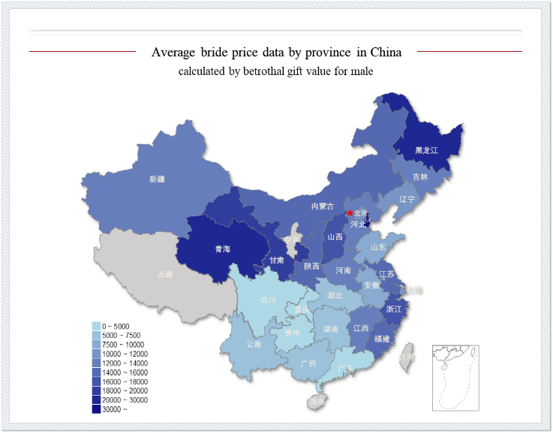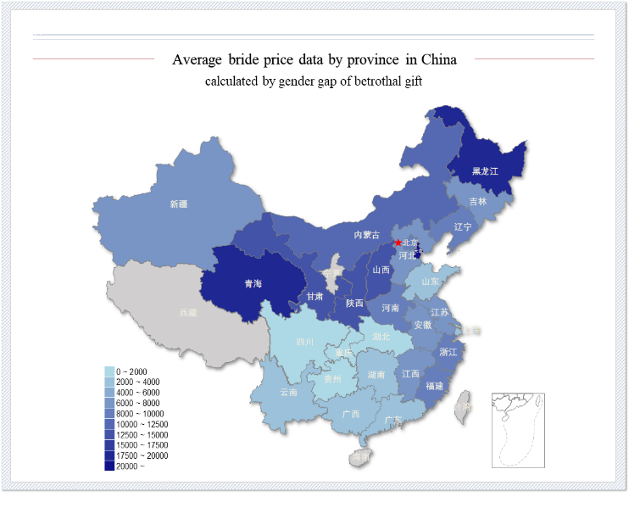

The two maps above show the average bride price of each province in China. From the left map we can tell that in the different provinces across China, the bride price is quite different. More specifically, the northern part of China and the Yangtze River Delta region have relatively higher bride prices. When I calculated the difference between the betrothal gift for males and females (the right map), I found that the bride price (male family pays) is higher than the dowry (female family pays) in northern China, while the value of the bride price and dowry in southern China is not too different.

3.2 WEATHER DATA AND CONSTRUCTION OF WEATHER SHOCKS

To examine how income shock affects the marriage age for young women, I exploit the exogenous rainfall shock as the proxy for local economic conditions. And this is an approach that is widely used in the economics literature. The rainfall is an exogenous event that had an effect on economic productivity, especially for rural household that relies on rain-fed agriculture. Droughts tend to decrease the agricultural output of that year, which has a negative effect on households' incomes.

To construct a measure of local droughts, I use the weather data from NOAA Center for Weather and Climate Prediction. In particular, I exploit exogenous variation in rainfall to estimate the causal effect of income shocks on the age of marriage. Negative rainfall shocks--droughts are measured as the absolute deviation of rainfall from the historical mean at the city level. For each city, I compute the historical mean level of annual precipitations (in millimeters) between 1980 and 2022. Then, I compute the rainfall deviations from the rainfall historical mean. To capture the level of droughts, I use the absolute value of the deviation for the years that have lower precipitations than the average level. And let droughts level equals 0 for all other years when the precipitations are equal to or higher than the average level. It can be calculated by the following formula:

${Drought}_{c,a}=|{precipitation}_{c,a}-mean|$*if ${precipitation}_{a}<$*  *mean*

${Drought}_{c,a}=0$*if ${precipitation}_{a}≥$ mean*

My measure of droughts ${Drought}_{i,c,a}$, is the droughts level of an individual i experienced at the age of a, living in city c.

For example, the variable ${Drought}_{g,c,18}$ measures the droughts level the girl g experienced, in city c in the age of 18. By using this measure of rainfall shocks, I can capture anomalously low rainfall relative to what is typically experienced in a particular location.

4. EMPIRICAL STRATEGY

The empirical analysis of the effects of social norms on an individual's outcomes (i.e. age of marriage) is typically complicated by the endogenous nature of the social norm itself. First, unobserved individual characteristics, such as physical appearance and cleverness may simultaneously influence the amount/existence of the bride price and the age of marriage, thus providing a spurious correlation between social norms and outcomes. Second, the age of marriage is likely to influence the amount of a bride price, again providing a biased estimate of the effect of bride price payments on the age of marriage. For this reason, I exploit exogenous variation in negative weather shocks (i.e droughts) across cities and different years to study the causal effects of income shocks on the girl's age of marriage. Here is the empirical model for woman i living in city c born in year y.

$Y_{i,c,y}=α+R_{i,c,y}β+λX_{i,c,y}+δ_{c}+γ_{y}+ϵ_{i,c,y}$ (1)

Where $Y_{i,c,y}$ is the age of marriage. $R_{i,c,y}$ is a vector containing the droughts that woman i has experienced before her marriage. $X_{i,c,y}$ is a set of individual control variable that includes the basic information of the girl’s family. The city fixed effect ($δ_{c}$) and year-of-birth fixed effect($γ_{y}$) are also included in the estimation equation, to capture the time-invariant village characteristics(e.g. richer versus poorer cities) and time-invariant cohort characteristics(e.g., marriage reforms in some particular year) that may be related to the probability of early marriage. My coefficients of interest are $β$, which capture how income shocks affect the age of marrying. A negative coefficient indicates that if a girl experiences an adverse income shock, she may marry at a relative early age.

5. EMPIRICAL RESULTS

5.1 Drought and Income

To ensure that the use of droughts as an indicator of income shock is valid, I examined the impact of droughts on local GDP. I combined panel data on GDP for each city in China from 1999-2022 with droughts data and conducted a simple fixed effects regression analysis. Table 2 shows that one unit of weather shock will reduce the city's GDP by RMB 2.093 billion. GDP1, GDP2 and GDP3 represent the GDP of the primary sector, the GDP of the secondary sector, and the GDP of the tertiary sector, respectively. These indicate that weather shock have a significant negative impact on the economic development of a region, and it can be an accurate indicator of income shock for households in this region.

|  |  |  |  |  |
| --- | --- | --- | --- | --- |
| **Table2:** Droughts and GDP Level | | | | |
|  |  |  |  |  |
| VARIABLES | GDP | GDP1 | GDP2 | GDP3 |
|  |  |  |  |  |
| Shock 3 Year Ago | -1.816*** | -0.135*** | -0.708*** | -1.026*** |
|  | (-8.94) | (-14.30) | (-8.64) | (-7.09) |
| Shock 2 Year Ago | -1.810*** | -0.130*** | -0.666*** | -1.011*** |
|  | (-8.56) | (-12.87) | (-7.57) | (-6.51) |
| Shock 1 Year Ago | -1.541*** | -0.101*** | -0.493*** | -0.830*** |
|  | (-7.16) | (-9.49) | (-5.35) | (-5.10) |
| shock | -2.093*** | -0.148*** | -0.844*** | -1.272*** |
|  | (-9.65) | (-13.93) | (-9.13) | (-7.80) |
|  |  |  |  |  |
| Observations | 7,268 | 6,232 | 6,233 | 6,233 |
| R-squared | 0.519 | 0.612 | 0.641 | 0.594 |
| Location FE | YES | YES | YES | YES |

5.2 Income Shock and Age of marriage

Table 3 reports the estimated coefficients for equation (1) separately for the full sample(columns 1-2) and the sample divided by the bride price(columns 3-4). The results show that if a girl's family has suffered from income shock in the past, she is more likely to marry earlier. More specifically, if there is a 1 unit decrease in precipitation in the previous year or the current year, the girl's marriage age will be 0.3% earlier. After controlling for the Birth Year fixed effect, income shock that happened 2 years and even 3years ago also significantly affects the age of marriage for girls, only to a lesser extent.

|  |  |  |  |  |
| --- | --- | --- | --- | --- |
| **Table 3:** Effect of Droughts on Age of Marriage | | | | |
|  | (1) | (2) | (1) | (2) |
| Age of Marriage | Full Sample | | BP>50% | BP<50% |
|  |  |  |  |  |
| Shock 3 Year Ago | 0.001 | -0.001** | -0.002** | -0.001 |
|  | (0.77) | (-1.99) | (-2.06) | (-0.95) |
| Shock 2 Year Ago | -0.000 | -0.002** | -0.003** | -0.001 |
|  | (-0.44) | (-2.13) | (-2.41) | (-0.65) |
| Shock 1 Year Ago | -0.002*** | -0.003*** | -0.004*** | -0.001 |
|  | (-2.64) | (-3.50) | (-3.99) | (-1.09) |
| Shock | -0.003*** | -0.003*** | -0.005*** | -0.002* |
|  | (-3.79) | (-4.56) | (-4.92) | (-1.71) |
|  |  |  |  |  |
| Observations | 56,396 | 56,396 | 29,893 | 26,502 |
| R-squared | 0.189 | 0.243 | 0.251 | 0.245 |
| Location FE | YES | YES | YES | YES |
| Birth Year FE | NO | YES | YES | YES |

In order to explore more deeply the role played by bride price, I take betrothal gift for males as a measure of bride price, calculate the average bride price in each region, and divided it into two groups for analysis: high bride price(BP>50%) and low bride price(BP>50%). The results show that the high bride price group(column 3) is consistent with the full sample, and the effect of income shock on age at marriage becomes larger. However, the coefficients of the low bride price group(column 4) are not significant, which indicates that when the bride price is low, income shock does not affect the age of marriage of girls. That is, the family does not respond to income shock by marrying their daughter.

Overall, these findings point out that bride price may be a source of insurance for households that are exposed to income shocks.

6. CONCLUSIONS

Despite the legal age limit for marriage set by the Chinese government, early marriage is still a not rare practice in China. Early marriage has many undesirable consequences, especially for women and their children, yet its reasons are poorly understood. In this paper, I examine the effect of negative weather shocks on the age of marriage for girls in China, where bride price is customary.

By using the survey dataset from CHARLS and exploiting droughts as an income shock proxy, this paper finds that girls who are exposed to adverse

income shocks tend to be married at a younger age. Moreover, the relationship between rainfall shocks and early marriage is stronger in areas that have higher bride price traditions.

The bride price may be an insurance for families exposed to income shocks, especially for places that have high bride prices. Regulating the high price of bride price and providing prompt and effective subsidies to families affected by income shock may be the solution to the phenomenon of early marriage.

References:

[1] Baez, J. E., Lucchetti, L., Genoni, M. E., & Salazar, M. (2017). Gone with the storm: rainfall shocks and household wellbeing in Guatemala. The Journal of Development Studies, 53(8), 1253-1271.

[2] Corno L, Voena A. Selling daughters: Child Marriage, Income Shocks and the Bride Price Tradition[J]. Working Paper, 2021.

[3] Corno, L., Hildebrandt, N., & Voena, A. (2020). Age of marriage, weather shocks, and the direction of marriage payments. Econometrica, 88(3), 879-915.

[4] Dong-mei LUO, Xiao-jin YAN, Pei-jin HU, Jing-shu ZAHNG, Yi SONG, & Jun MA. (2020). Subnational inequalities of early marriage and fertility among Chinese females from 1990 to 2010. Journal of Peking University (Health Sciences), 52(3), 479. (Chinese)

[5] Harper, C., Jones, N., Presler-Marshall, E., & Walker, D. (2014). Unhappily ever after. Slow and uneven progress in the fight against early marriage. Overseas Development Institute, London.

[6] Miguel, E., Satyanath, S., & Sergenti, E. (2004). Economic shocks and civil conflict: An instrumental variables approach. Journal of Political Economy, 112(4), 725-753.

[7] Parsons, J., Edmeades, J., Kes, A., Petroni, S., Sexton, M., & Wodon, Q. (2015). Economic impacts of child marriage: a review of the literature. The Review of Faith & International Affairs, 13(3), 12-22.